Arooj Saeed

CS 330

Assignment 2-3

Project Proposal

The image I select is the picture of modern kitchen as shown:

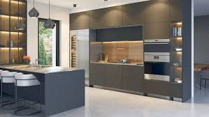

I want to create this from 2D to 3D shape. According to my analysis, it contains many shapes. The cabinets of the kitchen are mostly rectangle which can be drawn by 2 triangles. The lights on the top looks like pyramids. The side shelves resemble cube. The middle counter is the mixture of cube and triangle itself.

As mentioned previously, cubes, pyramids and triangles can be converted from 2D to 3D. As the rectangle part, it can be converted to 3D by joining 2 Triangles upside down. These are the good choices because these shapes are the basic shapes of the 3D scene. There is no limit to convert different objects from one form to another by using shapes.

According to my point of view, the plane of the picture can either be the kitchen floor or the side walls. Hence the side walls are representing the kitchen counter and shelves including stove and lights. The main objects of this picture are kitchen side shelves, shelves above counter and the lights on the top of the middle counter. These represents different shapes. Although, it will not be easy to create this image from 2D to 3, but we can still try.